**Application of Metaheuristics for Localization, Energy and Path Optimization in Sensor Network**



**Project Team**

|  |  |  |
| --- | --- | --- |
| **Sl. No.** | **Reg. No.** | **Student Name** |
| **1** | **15ETCS002008** | **Biswajit Basak** |
| **2** | **15ETCS002033** | **Rahul Kumar** |
| **3** | **15ETCS002036** | **Rohan Kumar** |
| **4** | **15ETCS002048** | **Tushar Agarwal** |

**Supervisor: Ms. Vaishali R Kulkarni**

**May – 2019**

**B. Tech. in Computer Science and Engineering**

**Faculty of ENGINEERING AND TECHNOLOGY**

## M. S. Ramaiah University of applied sciences

### Bengaluru -560054

## Faculty of engineering and technology



**Certificate**

*This is to certify that the Project titled “Application of Metaheuristics for Localization, Energy and Path Optimization in Sensor Network” is a bonafide work carried out in the Department of Computer Science and Engineering by Biswajit Basak, Rahul Kumar, Rohan Kumar, Tushar Agarwal bearing Reg. No. 15ETCS002008, 15ETCS002033, 15ETCS002036, 15ETCS002048 in partial fulfilment of requirements for the award of B. Tech. Degree in Computer Science and Engineering of M.S. Ramaiah University of Applied Sciences.*

**May – 2019**

**Ms. Vaishali R Kulkarni**

**Dr. P.V.R. Murthy Dr. M. Arulanantham**

**Head – Dept. of CSE Dean-FET**

Declaration

*Application of Metaheuristics for Localization, Energy and Path Optimization in Sensor Network*

The project work is submitted in partial fulfilment of academic requirements for the award of B. Tech. Degree in the Department of Computer Science of the Faculty of Engineering and Technology of M. S. Ramaiah University of Applied Sciences. The project report submitted herewith is a result of our own work and in conformance to the guidelines on plagiarism as laid out in the University Student Handbook. All sections of the text and results which have been obtained from other sources are fully referenced. We understand that cheating and plagiarism constitute a breach of University regulations, hence this project report has been passed through plagiarism check and the report has been submitted to the supervisor.

|  |  |  |  |
| --- | --- | --- | --- |
| **Sl. No.** | **Reg. No.** | **Student Name** | **Signature** |
| **1** | **15ETCS002008** | **Biswajit Basak** |  |
| **2** | **15ETCS002033** | **Rahul Kumar** |  |
| **3** | **15ETCS002036** | **Rohan Kumar** |  |
| **4** | **15ETCS002048** | **Tushar Agarwal** |  |

**Date: May 2019**

# Acknowledgements

It is with extreme pleasure and pride that we present our B-Tech. dissertation titled “***Application of Metaheuristics for Localization, Energy and Path Optimization in Sensor Network***”. We would like to express our sincere thanks and gratitude to the following people, who stood by us throughout, helping us with much required inputs, guidance, knowledge and supported us.

We take great pleasure to express our sincere thanks and gratitude to academic project guide Ms. **Vaishali R Kulkarni** Asst. Professor Department of CSE, for her support, guidance and suggestions throughout the project which is leading this project for the completion.

We express our sincere thanks to**, Dr. M. Arulanantham**, our respected Dean and to **Dr. P.V.R. Murthy,** Head of Department of Computer Science and Engineering, for their kind cooperation and support toward out dissertation, and to the management of Ramaiah University of Applied Science for their continued support. We are thankful to the staff members of the Computer Science and Engineering, RUAS for giving us good support and suggestion.

Lastly, we would like to thanks our parents and friends for their continued support, encouragement and motivation and God for paving our way of success in this object.

# Summary

This project is about the application of metaheuristics for localization, energy and path optimization in sensor network. These are the three challenges that will be addressed in this project and finally the developed solution will be compared with the traditional approach. Wireless sensor networks (WSN) are networks of autonomous sensor nodes (motes) and one or more base stations. Possible applications of WSN are in monitoring and sensing e.g.- Traffic surveillance, health care, natural calamities, environmental monitoring etc. Challenges in WSN are deployment, routing, localization and energy consumption. There is a need to address these challenges and provide a robust, autonomous, flexible and inexpensive solution. Swarm Intelligence (SI) algorithms have such qualities [1].

This project mainly focuses on comparing the traditional approaches with the bio-inspired approaches in dealing with the three issues which are – path planning, localization and energy optimization. By completing this project, people will come to know about the difference between the two approaches and start using the better one.

Methods and Methodologies

* To do literature survey in SI algorithms and challenges in WSN.
* Current technology being used
* Collecting information about the issues in WSN
* To apply SI algorithms to achieve accurate location estimation, energy optimization and deployment of sensors in WSN.
* Localization issue of WSN will be solved using Particle Swarm Optimization (PSO).
* Path Planning issue will be solved using Mobile Anchor with Trilateration.
* Energy Consumption issue will be solved using LEACH (Low-Energy Adaptive Clustering Hierarchy) protocol.
* To implement and test the simulations.
* Python will be used for implementation.
* Test Scenarios with known data.
* Test Scenarios with unknown data.
* To perform comparative analysis of traditional deterministic algorithms with bio-inspired SI algorithms.
* Efficiency of SI Algorithm.
* Energy Consumption of Wireless Sensors.
* To document the project report.

This project highlights the three challenges in wireless sensor network which are localization, energy and path optimization. In order to deal with these challenges, there lies the traditional approach and also the bio-inspired approach. This project aims at comparing both the approaches and highlighting the better one. Things like LEACH protocol and trilateration algorithm for localization will come into picture.

# Table of Contents

Certificate ………………………………………………………………………………………………………………..…(ii)

Declaration………………………………………………………………………….……...................................(iii)

Acknowledgements……………………………………………………………..……………………………….…….(iv)

Summary …………………………………………………..……………………………………………………………..…(v)

Table of Contents………………………………………….………………………………………………………..…. (vi)

Chapter-1: Introduction………………………………………………………..…………..…………………………01

* 1. Introduction………………………………………………………………………………………..……...01
  2. Scope…………………………………………………………………………………..………………..…...01
  3. Conclusion………………………………………………………………………………………………..…02

Chapter-2: Background Theory …………………………………………………………………………….………03

2.1 LEACH Protocol …………………………………………………………………………………..……..03

2.2 Wireless Sensor Network (WSN) ………………………………………………………………..04

2.3 Ant Colony Optimization (ACO) ………………………………………………………………….04

2.4 Particle Swarm Optimization (PSO) …………………………………………………………….05

2.5 Literature Survey …………………………………………………………………………………….….06

2.6 Conclusion …………………………………………………………………………………………….……07

Chapter-3: Aim and Objectives ……………………………………………………………………………….…..08

3.1 Title of the Project …………………………………………………………………………….………08

3.2 Aim of the Project ……………………………………………………………………………….…….08

3.3 Objectives of the Project ……………………………………………………………………….….08

3.4 Methods and Methodology ………………………………………………………………….…..09

3.5 Conclusion .………………………………….…………………………………………………….….….10

Chapter-4: Problem Solving .………………………………………..…………………………………….….……11

4.1 Design and Development .…………………………………...………………………….….……11

4.2 Design, Simulation and Implementation .……………………………….…….….………16

4.3 Design and Simulation .………….………………………………………………….………….…16

4.4 Formulation and Testing .…………………….………………………………………………..16

4.5 Clinical Study of WSN ………………………………..………………………………………….17

4.6 Field Study of WSN and Bio-inspired algorithm ………………………………….…17

* 1. Product Concepts and Development .……………………………………………………17
  2. Data Collection, Modelling and Simulation .………………………………………….18
  3. Design, Modelling and Analysis .…………………………………………………………..18

4.10 Conclusion .…………………………………..……………………………………………………18

Chapter-5: Results .……………………………..…………………………………………………………………..19

5.1 Graphs for Trilateration .…………………………………..…………………………………19

5.2 Graphs for PSO .………………………….……...………………………………………………31

5.2 Comparison Graph .…………………...………………………………………………………36

5.3 Graph for Mobile Anchor .……..……………………………………………………………37

5.3 Analysis .………………………………………….………………………………….………………38

Chapter-6: Project Costing .………..………………………………………………………….………………40

6.1 Introduction .…………..…………………………………………………………..………….…40

6.2 Project Cost .…………..……………………………………………………………..……………40

6.3 Summary .…………..…………………………………………………………………..……….…40

Chapter-7: Conclusions and Suggestions for Future Work.……………………………..…….. 41

References .……………..…………………………………..…………………………………………………..……43

# 1. Introduction

* 1. **Introduction**

Different issues that are going to be explored are basically different types of challenges in WSN. The issues are regarding the deployment of sensors which are deployed randomly at different positions. The position of the sensor will have latitude, longitude and height. Another issue is regarding routing. Routing is basically the path the cluster head is going to follow to connect to different hops. Another issue is localization. Localization is basically finding the total number of nodes that have been localized. It will help to trace the data based on the type of nodes. Last issue is regarding the energy consumption. Basically, all the nodes are connecting to the base station, which requires more energy consumption as all the nodes are communicating to the base station. Battery energy consumption is also high due to this as all the nodes are communicating to the base station [2].

Hence, there is a need to address the challenges that have been mentioned in the above paragraph. In order to tackle those challenges, it is required to provide solution. The solution can be provided through Swarm Intelligence (SI) algorithms which have different qualities which are robust, autonomous, flexible and inexpensive.

* 1. **Scope**

The project mainly focuses on comparing the traditional approaches with the bio-inspired approaches in dealing with the three issues which are – path planning, localization and energy optimization. By focusing on the central topic of the project, the project goal can be achieved. It is needed to implement and test the simulations. SI algorithms has to be applied to achieve accurate location estimation, energy optimization and deployment of sensors in WSN. By completing this project, people will come to know about the difference between the two approaches. Finally, people will start using the better approach [3].

In order to apply SI algorithms which will be done to achieve accurate location estimation, energy optimization and deployment of sensors in WSN. The localization issue of WSN will be solved using Particle Swarm Optimization (PSO). Path Planning issue will be solved using Trilateration. Energy optimization will be solved using LEACH Protocol.

For the implementation and testing of the simulations, Python will be used. Here, test scenarios with known data. In order to perform comparative analysis of traditional deterministic algorithm, the bio-inspired SI algorithms are considered which increases the efficiency of SI Algorithm and energy Consumption of Wireless Sensors.

The project also aims to perform comparative analysis of traditional deterministic algorithms with bio-inspired SI algorithms [4].

**1.3 Conclusion**

The conclusion of the chapter is that in this chapter the introduction on the project is being done. The illustration the scope and the organization of the project is being done. A WSN (Wireless Sensor Network) can be defined as a network of devices capable of communicating through wireless links the information collected from a monitored field. The data is transmitted via multiple nodes and the data is connected to other networks with a gateway. The limitations that pose to the WSN include various environmental factors such as blockage by plants, animals, building etc, energy loss due to continuous transmission of energy, locate various nodes that are present in the networks. Hence to prevent these limitations and to push forward the applications, various bio-inspired algorithms are used which reduced the issues that are caused in the environment or are a part of the WSN itself. These bio-inspired algorithms will help resolve the issues that our project is trying to address. Different scope of the project has been mentioned which gives a brief insight of the project.

# 2.Background Theory

**2.1 LEACH Protocol**

LEACH stands for Low-Energy Adaptive Clustering Hierarchy. LEACH's goal is to reduce the energy consumption needed to create and maintain clusters to enhance a WSN's lifetime. LEACH is a hierarchical protocol in which the majority of nodes are transmitted to cluster heads and the cluster heads aggregate and compress the data and forward it to the base station. For P rounds, where P is the desired percentage of cluster heads, nodes that were cluster heads cannot become cluster heads again. Each node then has a 1/P likelihood of becoming a cluster head again. Each node not a cluster head selects the closest cluster head at the end of each round and joins that cluster. The cluster head then creates a schedule to transmit its data for each node in its cluster [5].

The main objectives of LEACH are:

* Extension of the network lifetime
* Reduced energy consumption by each network sensor node
* Use of data aggregation to reduce the number of communication messages

LEACH's basic operations are organized in two separate phases. The first phase consists of two steps in the selection of cluster heads and the formation of clusters. The second phase is the stable-state phase that focuses on collecting, aggregating, and delivering data to the base station. The setup duration is assumed to be relatively shorter than the t-state phase in order to minimize the overhead protocol [6].

**2.2 Wireless Sensor Network**

A WSN can be defined as a network of devices capable of communicating through wireless links the information collected from a monitored field. The data is transmitted via multiple nodes and the data is connected to other networks with a gateway.

WSN were initially designed to facilitate military operations but its application has since been extended to health, traffic, and many other consumer and industrial areas. A WSN consists of sensor nodes. The equipment for the sensor node includes a radio transceiver, an antenna, a microcontroller, an electronic interfacing circuit, and a source of energy, usually a battery. Sensor nodes can also vary in size from small to large. As such, their prices also vary depending on the functionality parameters of a sensor like energy consumption, computational speed rate, bandwidth, and memory [7].

**2.3 Ant Colony Optimization (ACO)**

The ACO is for finding optimal paths that is based on the behaviour of ants searching for food. At first, the ants wander randomly. When an ant finds a source of food, it walks back to the colony leaving " pheromones” that show the path has food. When other ants come across the markers, they are likely to follow the path with a certain probability. If they do, they then populate the path with their own markers as they bring the food back. As more ants find the path, it gets stronger until there are a couple streams of ants traveling to various food sources near the colony.

Because the ants drop the pheromones every time they found, they bring food, shorter paths are more likely to be stronger than longer path, hence optimize the "solution." In that time, some ants are still randomly searching for closer food sources. A similar approach of this can be used to find near-optimal solution to the traveling salesman problem [8].

The route is no longer populated with pheromones and slowly declines once the food source is depleted. Because the ant-colony works on a very dynamic system, in graphs with changing topologies, the ant colony algorithm works very well. Examples of such systems include computer networks and artificial intelligence (AI) simulations of workers

**2.4 Particle Swarm Optimization (PSO)**

PSO is a population-based technique of stochastic optimization inspired by bird flocking social behaviour. The system is initialized through the updating of generations with a population of random solutions and searches for optima. The potential solutions, called particles, fly through the problem space in PSO by following the current optimum particles. The PSO algorithm simultaneously maintains several potential solutions. Each solution is evaluated by an objective function to determine its fitness during each iteration of the algorithm. Each solution in the fitness landscape (search space) is represented by a particle. To find the maximum value returned by the objective function, the particles "fly" or "swarm" through the search space [9].

It is shown that PSO has a faster, cheaper way of achieving better results compared to other methods. Another reason PSO is appealing is that few parameters need to be adjusted. One version works well in a wide variety of applications, with slight variations. PSO has been used for approaches that can be used across a wide range of applications, as well as for specific requirement-focused applications [10].

**2.5 Literature Survey**

|  |  |  |  |  |  |  |
| --- | --- | --- | --- | --- | --- | --- |
| **Sl No** | **Author name** | **Journal name and year of publication** | **Research focus** | **Tools and algorithms used.** | **Demerits** | **Conclusion** |
| **1** | Mohamed Sandeli, Souham Meshoul | Computational Intelligence Approaches for Energy  Optimization in WSN | One of its main  goals is to obtain approximate solutions to NP-hard problems efficiently. | ACO | Major challenges in WSN lies in the  energy constraint and computation resources available at the sensor nodes | The effectiveness of the proposed methods has been assessed and compared with other peers that use clustering technique (a traditional protocol LEACH) |
| **3** | Frank Comeaua, Nauman Aslam | Analysis of LEACH Energy Parameters | Analyzes how the parameter values used in the LEACH protocol vary | LEACH | Parameter selection has a significant effect on the lifetime of the network | LEACH is a popular protocol used in analyzing and simulating WSN. |
| **4** | Cogn Neurodyn | An improved WSN genetic algorithm-based localization algorithm | The objective is to minimize the total estimation error of the WSN location problem | ACO | To increase the accuracy of positioning and also the accuracy of positioning is relatively low | Localization of nodes is an important issue in WSNs, as many applications depend on knowing where sensor nodes are located |
| **5** | James Blondin | Applications in Parameterization of Classifiers [2016] | For PSO itself, you need to find optimal parameters | PSO | The optimization process should be run several times because of randomized aspects to determine if the results are consistent. | Important acceleration with PSO over exhaustive search |
| **6** | Eric W. Weisstein | Real world application of ACO | ACO has been and remains a fruitful paradigm for effective algorithms for combinatorial optimization solutions | ACO | Another common area for testing the effectiveness of ACO algorithms is scheduling problems | Both the effectiveness of its application and its theoretical grounding have shown that ACO is one of the most successful paradigms in the metaheuristic area. |

**2.6 Conclusion**

In this chapter, the background theory has been depicted. Different key aspects has been considered and explained. Different algorithms that has been used in the project has been explained. This chapter also contains the table of the literature survey. The table consists of different author name, journal name, focus, demerit and conclusion of different papers. In the next chapter aim and objectives would be demonstrated.

# 3. Aim and Objectives

This chapter focuses on defined title and Aim of the project correctly and clearly. Later this chapter also includes the required objectives that needed to be fulfilled in order to complete this project.

## 3.1 Title

Application of metaheuristics for localization, energy and path optimization in Sensor Network.

## 3.2 Aim

To apply SI algorithms to address the challenges in localization, energy consumption and path optimization of sensors in WSN.

## 3.3 Objectives

1. To do literature survey in SI algorithms and challenges in WSN.
2. To apply SI algorithms to achieve accurate location estimation, energy optimization and deployment of sensors in WSN.
3. To implement and test the simulations.
4. To perform comparative analysis of traditional deterministic algorithms with bio-inspired SI algorithms.
5. To document the project report.

## 3.4 Method and Methodology

|  |  |  |  |
| --- | --- | --- | --- |
| **Objective No.** | **Statement of the Objective** | **Method/ Methodology** | **Resources Utilised** |
| 1 | To do literature survey in SI algorithms and challenges in WSN. | 1.1 Current technology being used  1.2 Collecting information about the issues in WSN | IEEE project paper and reputed websites along with Books from orally Publications. |
| 2 | To apply SI algorithms to achieve accurate location estimation, energy optimization and deployment of sensors in WSN. | 2.1 Localization issue of WSN will be solved using ACO.  2.2 Path Planning issue will be solved using PSO.  2.3 Energy Consumption issue will be solved using Firefly Algorithm | SI algorithms, Research papers |
| 3 | To implement and test the simulations. | 3.1 MATLAB and Python will be used for implementation.  3.2 Test Scenarios with known data.  3.3 Test Scenarios with unknown data | Python and MATLAB |
| 4 | To perform comparative analysis of traditional deterministic algorithms with bio-inspired SI algorithms. | 4.1 Efficiency of SI Algorithm  4.2 Energy Consumption of Wireless Sensors | Developed code |
| 5 | To document the project report. |  | MS Word |

**3.5 Conclusion**

In this chapter, the aim of the project has been depicted. The objectives that are to be fulfilled are also listed. This chapter also contains the objective table that are used followed. The table contains statement of the objective, methodologies and the resources utilized. In the next chapter the problem-solving approach would be demonstrated.

# 4. Problem Solving

* 1. **Design and Development**

In this part the algorithm that will be used for the traditional methods will be designed. This designed traditional methods will then be compared against bio inspired algorithms. The traditional methods constitute of algorithms such as LEACH protocol, trilateration and path planning using mobile anchors. These methods will be compared with their respective bio inspired methods such as firefly algorithm, ACO and PSO. Hence these bio inspired algorithms are also to be designed. And at the end the efficiency and the performance measure will be illustrated or tabulated.

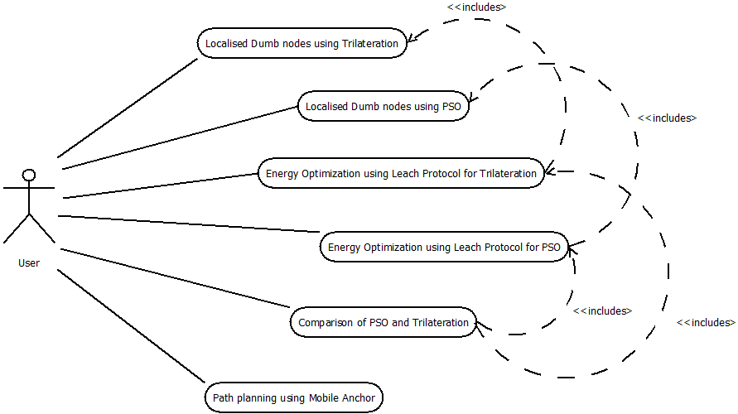

**Figure 1: Use case diagram for Interface**

In this design, we can see that the user can do some task such as localised the dumb nodes using Trilateration and PSO. The energy optimization using LEACH protocol for Trilateration and PSO can be done. Then the user can the compare PSO and Trilateration based on the time taken and error. The mobile anchor will help path planning.

Figure 2: Screenshot of the block diagram of the LEACH

This figure shows the detailed block diagram for LEACH protocol. It basically tries to increase the lifetime of WSN by dividing the nodes into clusters and thereby just allowing nodes to communicate with respective cluster heads. Only cluster heads are allowed to communicate with the base station and also the selection of cluster heads is randomized so that different nodes are elected as cluster heads.

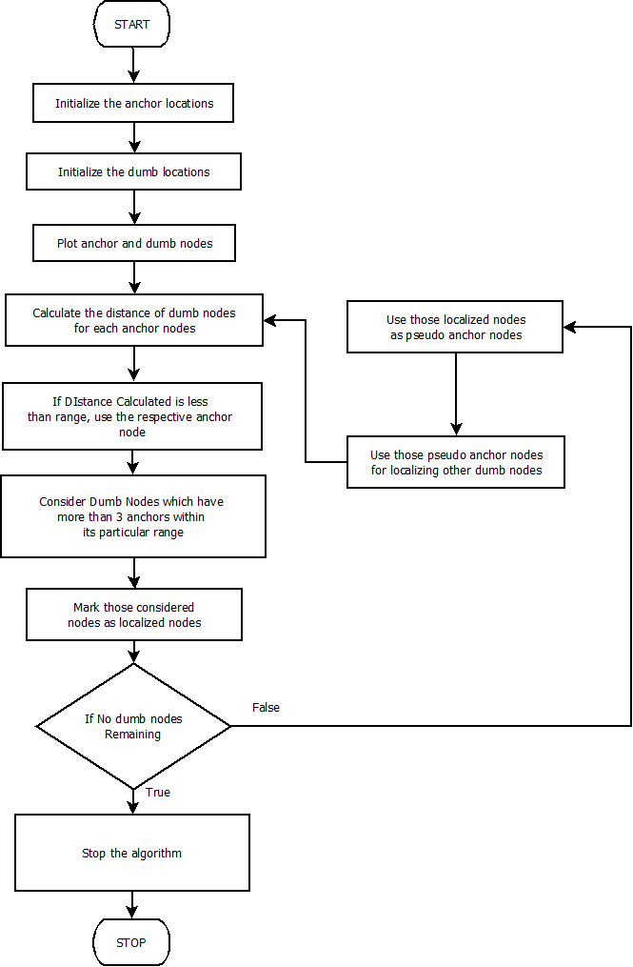

Figure 3: Screenshot of the block diagram for Trilateration.

This is the flowchart for trilateration. In this process anchor nodes are used to localize dumb nodes and those localized dumb nodes are used to localize more number of nodes. The name trilateration is used since the localized dumb nodes falls between three anchor nodes. This flowchart explains how the algorithm is used for solving our problem.

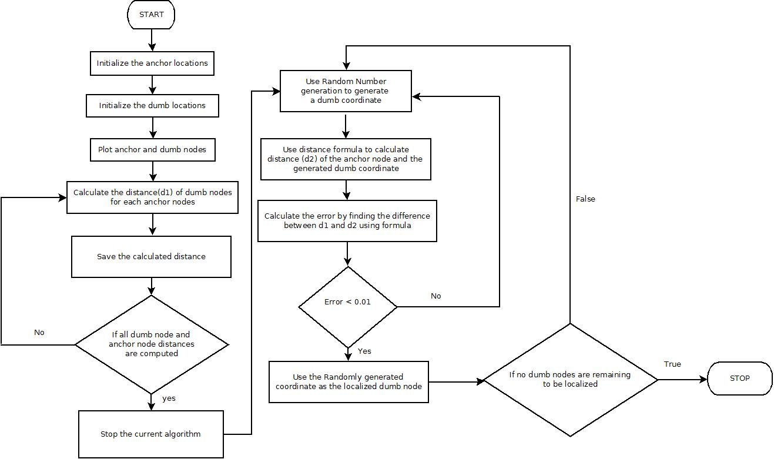

Figure 4: Screenshot of block diagram for PSO.

This is the flowchart which demonstrates localization using PSO. Here minimization of error has been performed and the nodes having less error are localized.

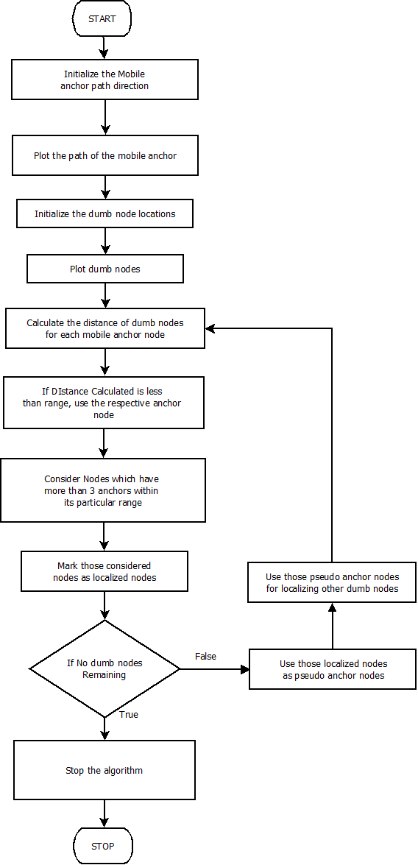

Figure 5: Screenshot of the block diagram of Mobile Anchor.

This is the flowchart which demonstrated the trilateration algorithm used for mobile anchor to solve path planning problem. Here the mobile anchors are given specific coordinates to move from one point to the other point. Any dumb nodes that falls between the coordinates of the moving anchor nodes gets localized.

* 1. **Design, Simulation and Implementation**

For the design purpose, the algorithm for the traditional methods such as LEACH protocol, trilateration and path planning using mobile anchors will be written. Also, the algorithms for the bio inspired techniques such as firefly algorithm, ACO and PSO will also be demonstrated. For the simulating and the implementation purpose, both MATLAB and Python will be used. There will be set of different programs that runs the traditional and bio inspired algorithms. The results of both these algorithms will be taken into consideration. Based upon the results a conclusion is to be drawn that which algorithm is suitable for a particular problem/scenario.

* 1. **Design and Simulation**

The design of these algorithms will consist of their actual working principle. The design will also contain some basic mathematical algorithms such as distance metrics, mean square error etc. The simulation of these algorithms will be done in both python and MATLAB. Simulation will be demonstrated using graphs and some mathematical results from the MATLAB and python scripts.

* 1. **Formulation and Testing**

The traditional algorithms and the bio inspired algorithms that are designed will be tested using random data. First the result from the traditional algorithm will be taken into consideration and then the result from the bio inspired algorithm will be taken. These results will be compared against each other to measure both the similarity and the dissimilarity measure. These tests will be performed for many sets of random data or known data.

* 1. **Clinical Study of WSN**

A WSN can be defined as a network of devices that can communicate the information gathered from a monitored field through wireless links. The data is forwarded through multiple nodes, and with a gateway, the data is connected to other networks. Various wireless sensory has their own limitations. The limitations that pose to the WSN include various environmental factors such as blockage by plants, animals, building etc, energy loss due to continuous transmission of energy, locate various nodes that are present in the networks. All these factors when add up together makes WSN difficult to implement in certain areas. Hence to prevent these limitations and to push forward the applications, various bio-inspired algorithms are used which reduced the issues that are caused in the environment or are a part of the WSN itself. These Bio inspired algorithm will help resolve the issues that our project is trying to address.

* 1. **Field Study of Wireless Sensor Networks and Bio-inspired algorithm**

The field study includes a detailed study about WSN which are networks of distributed autonomous nodes that can sense their environment cooperatively. WSN+ are used in diverse applications such as environment and habitat monitoring, structural health monitoring, healthcare, home automation, and traffic surveillance. They are also used in monitoring applications. They are also able to perceive their environment through onboard sensors. WSN have many issues regarding transmission of data, localization, energy consumption etc. By using certain bio inspired algorithms these limitations may be minimized. In bio inspired algorithm there are certain algorithms which addresses these issues.

* 1. **Product Concepts and Development**

The product or the scripts that will be implemented will be based on various traditional and bio inspired algorithms. The traditional concepts that will be used are LEACH protocol, trilateration and path planning using mobile anchors. And the bio inspired concepts that the program will demonstrate are firefly algorithm, ACO and PSO.

* 1. **Data Collection, Modelling and Simulation**

The data that is used to model the anchors and the dumb nodes are generated randomly. For the generation of the nodes, the python script is used which plots all these points. Then these points are to be localized, clustered and the energy efficiency is computed; and the data is presented for both the traditional and bio inspired algorithm and compared for the best.

* 1. **Design, Modelling and Analysis**

For both the traditional and the bio inspired algorithms the tests will be demonstrated and then the result will be compared against each other. This will be done for the known and the unknown data. Hence for every data that is provided to the script the script is going to display results for both of the techniques and this result will be compared with both the traditional and the bio inspired algorithm.

For the analysis part, the results will be compared for the both traditional and the bio inspired algorithm and certain factors which are being targeted to be solved will be solved by both of these algorithms. And the results of all the algorithms will be demonstrated.

* 1. **Conclusion**

In this chapter, the problem-solving approach has been demonstrated. The preamble to this chapter has been stated. This chapter contains the design part of the project. The block diagram for different algorithms has been provided. The design, simulation and implementation has been done. Product concept and development has been also illustrated. In the next chapter the result of the project has been demonstrated.

# 5. Results

This section includes screenshot of the result showing localization as well as LEACH protocol for energy efficient communication.

**5.1 Graphs for Trilateration**

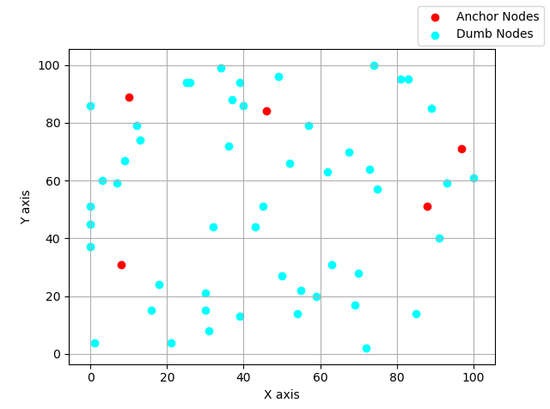

Figure 6: Graph for Localization

The above graph represents the anchor nodes marked as red and dumb nodes marked as cyan. This is the actual graph which represents the nodes that are displayed in the environment.

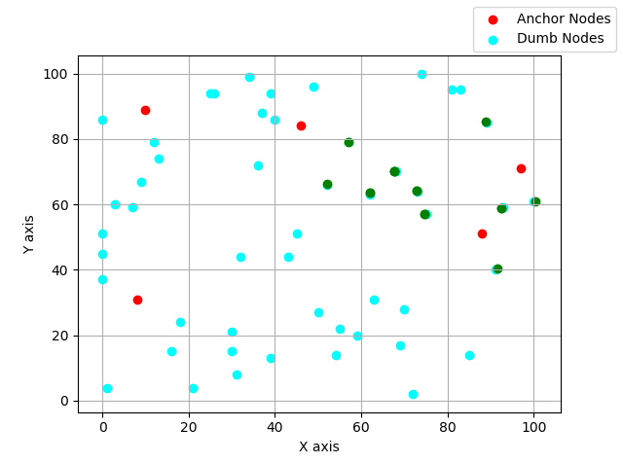

Figure 7: Graph for localization after 1st iteration

In the above graph, the anchor nodes localized some of the nodes using trilateration. This is the first iteration where some of the dumb nodes gets localized. The actual anchor nodes are marked as red, the pseudo anchor nodes are marked as green and the remaining dumb nodes are marked as cyan.

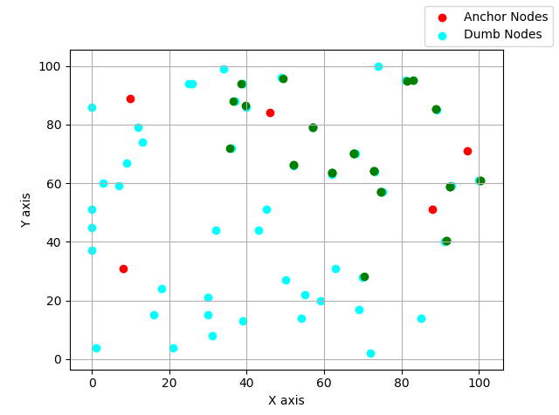

Figure 8: Graph for localization after 2nd iteration

In the above graph, the anchor nodes localized some of the nodes using trilateration. This is the second iteration where more dumb nodes get localized. The actual anchor nodes are marked as red, the pseudo anchor nodes are marked as green and the remaining dumb nodes are marked as cyan.

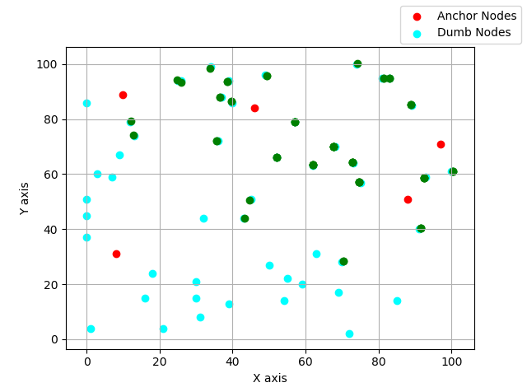

Figure 9: Graph for localization after 3rd iteration

In the above graph, the anchor nodes localized some of the nodes using trilateration. This is the third iteration where more dumb nodes get localized. The actual anchor nodes are marked as red, the pseudo anchor nodes are marked as green and the remaining dumb nodes are marked as cyan.

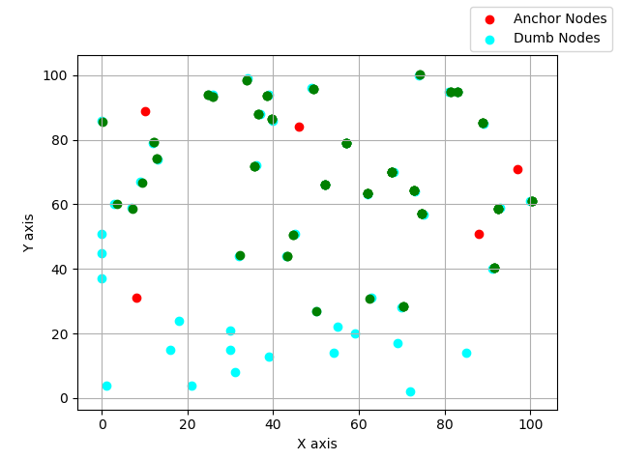

Figure 10: Graph for localization after 4th iteration

In the above graph, the anchor nodes localized some of the nodes using trilateration. This is the fourth iteration where more dumb nodes get localized. The actual anchor nodes are marked as red, the pseudo anchor nodes are marked as green and the remaining dumb nodes are marked as cyan.

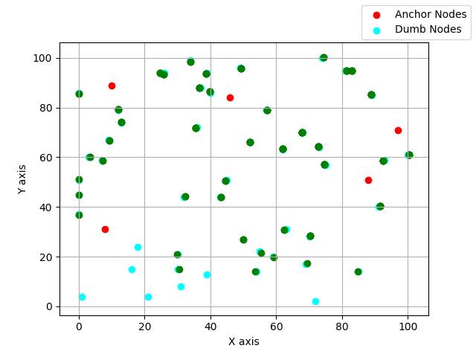

Figure 11: Graph for localization after 5th iteration

In the above graph, the anchor nodes localized some of the nodes using trilateration. This is the fifth iteration where more dumb nodes get localized. The actual anchor nodes are marked as red, the pseudo anchor nodes are marked as green and the remaining dumb nodes are marked as cyan.

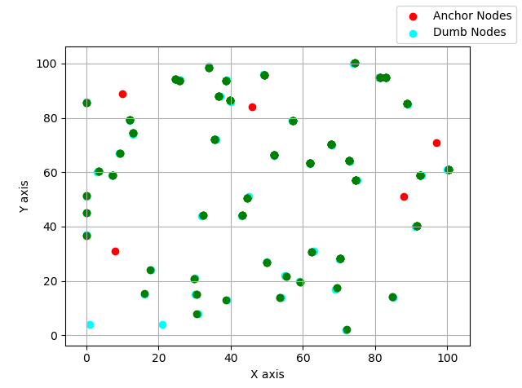

Figure 12: Graph for localization after 6th iteration

In the above graph, the anchor nodes localized some of the nodes using trilateration. This is the sixth iteration where more dumb nodes get localized. The actual anchor nodes are marked as red, the pseudo anchor nodes are marked as green and the remaining dumb nodes are marked as cyan.

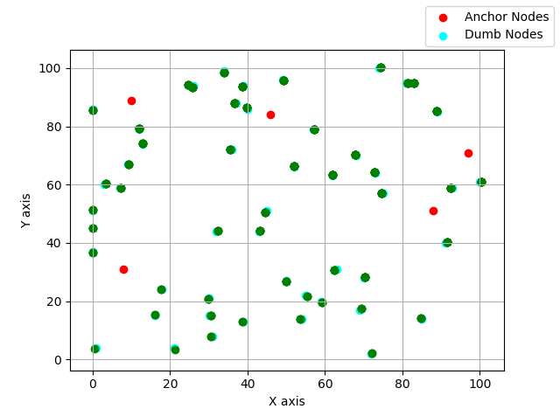

Figure 13: Graph for localization after 7th iteration

In the above graph, the anchor nodes localized some of the dumb nodes using trilateration. This is the eighth iteration where more dumb nodes get localized. The actual anchor nodes are marked as red, the pseudo anchor nodes are marked as green and the remaining dumb nodes are marked as cyan. This is the last iteration.

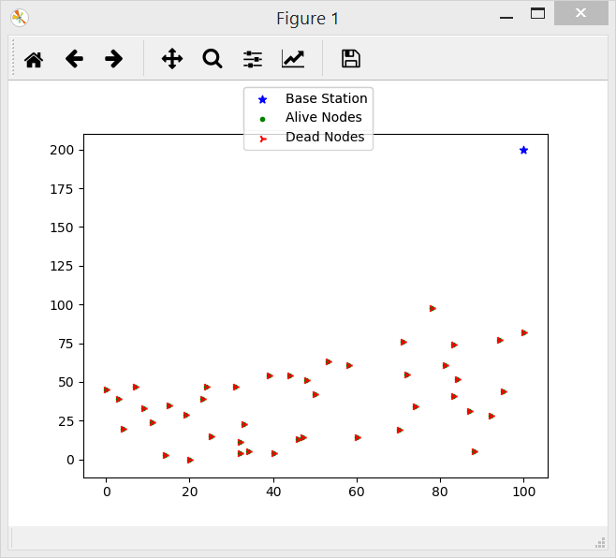

Figure 14: Graph showing different localized nodes at their co-ordinates for Trilateration.

This graph shows different localized nodes at their particular coordinates for trilateration. In the beginning all the nodes were alive, gradually they started dying as they started losing their energy because of the communication with base station and cluster head. All the nodes are marked as red because they died at the end.

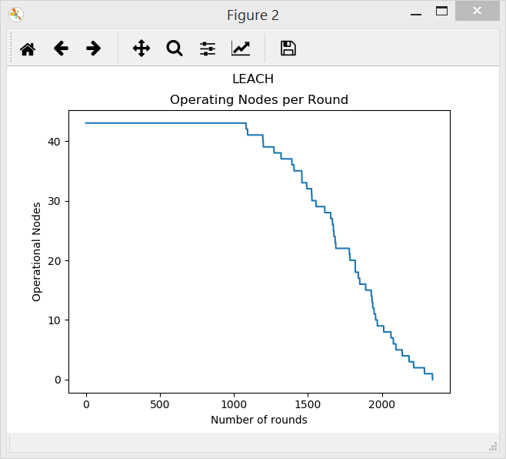

Figure 15: Graph of operating nodes vs number of iterations for Trilateration.

The above figure shows the number of operating nodes vs number of iterations. As the number of iterations increases, number of nodes that are alive decreases. This happens because as iteration progresses, nodes continue to lose their energy because of the communication that they carry out with the base station as well as cluster heads.

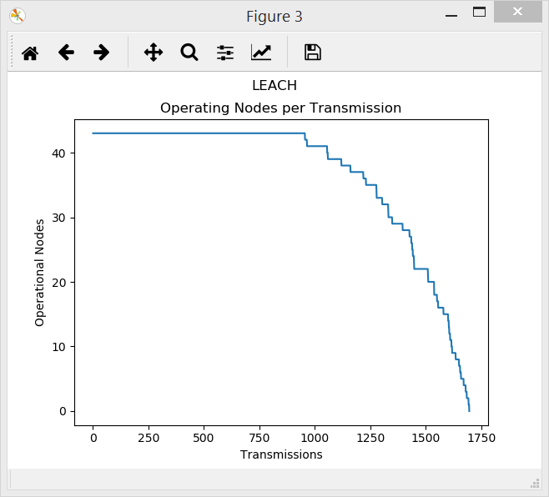

Figure 16: Graph of operating nodes vs number of transmissions for Trilateration.

The above figure shows the number of operating nodes vs number of transmissions. As the number of transmissions increases, number of nodes that are alive decreases. This happens because as iteration progresses, nodes continue to lose their energy because of the communication that they carry out with the base station as well as cluster heads.

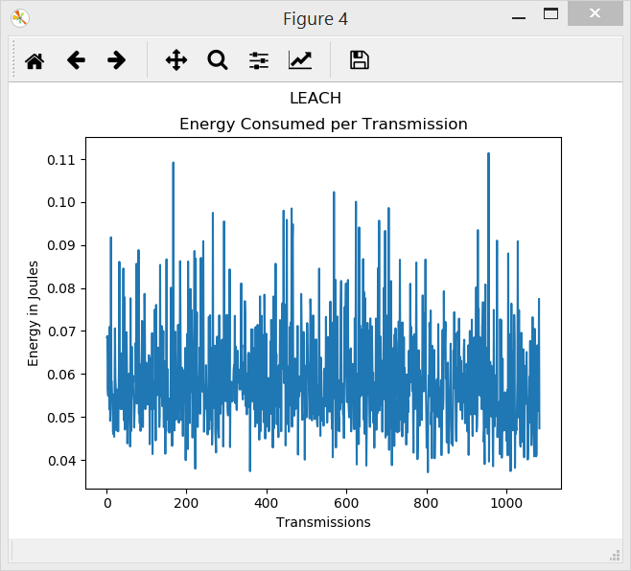

Figure 17: Graph of energy consumed vs no. of transmissions for Trilateration.

This graph shows energy consumed in every transmission. In every transmission some amount of energy is dissipated because nodes communicate with base station as well as Cluster Head. In every transmission whatever energy is consumed has been plotted in this graph.

**5.2 Graphs for PSO**



Figure 18: Graph shows anchor nodes, localized nodes and dumb nodes for PSO.

In this graph, the co-ordinates of the anchor nodes, localized nodes and dumb nodes are shown. The red dots demonstrate the anchor nodes, the green dots demonstrate the localized nodes and the cyan dots demonstrates the un-localized nodes. Here, it can be seen that the PSO algorithm is able to localize more nodes with exact location but the time taken is more to localize a dumb node.

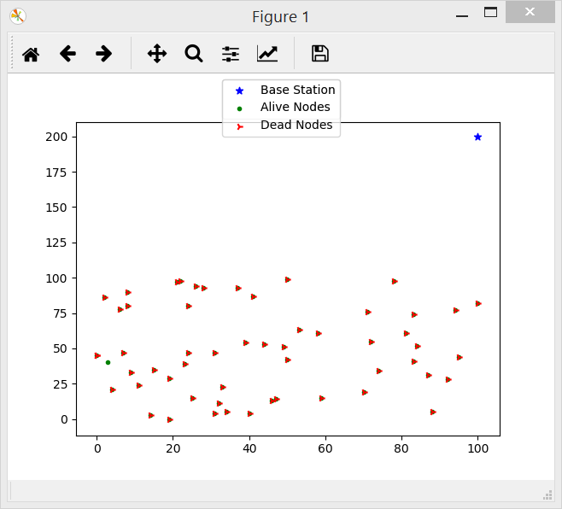

Figure 19: Graph showing different localized nodes at their co-ordinates for PSO

This graph shows different localized nodes at their particular coordinates for PSO. In the beginning all the nodes were alive, gradually they started dying as they started losing their energy because of the communication with base station and cluster head. All the nodes are marked as red because they died at the end.

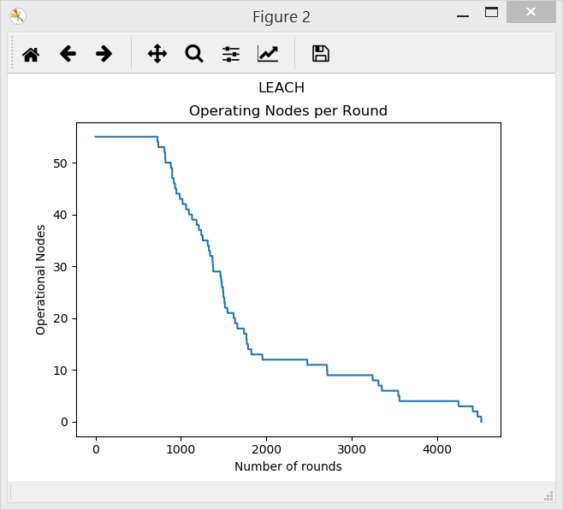

Figure 20: Graph of operating nodes vs number of iterations for PSO

The above figure shows the number of operating nodes vs number of iterations. As the number of iterations increases, number of nodes that are alive decreases. This happens because as iteration progresses, nodes continue to lose their energy because of the communication that they carry out with the base station as well as cluster heads.

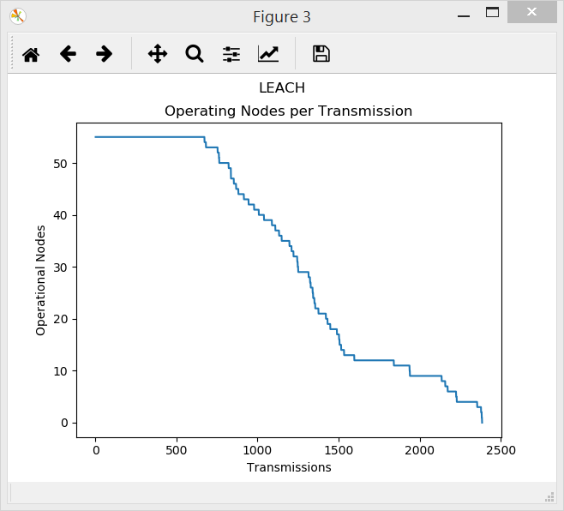

Figure 21: Graph of operating nodes vs number of transmissions for PSO

The above figure shows the number of operating nodes vs number of transmissions. As the number of transmissions increases, number of nodes that are alive decreases. This happens because as iteration progresses, nodes continue to lose their energy because of the communication that they carry out with the base station as well as cluster heads.

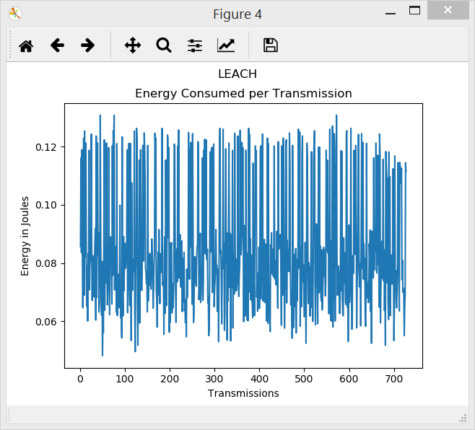

Figure 22: Graph of energy consumed vs no. of transmissions for PSO.

This graph shows energy consumed in every transmission. In every transmission some amount of energy is dissipated because nodes communicate with base station as well as Cluster Head. In every transmission whatever energy is consumed has been plotted in this graph.

**5.3 Comparison for PSO and Trilateration**

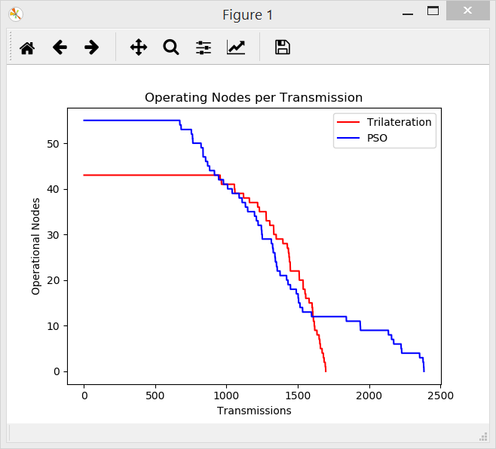

**Figure 23: Graph for comparing alive nodes of PSO with trilateration**

This graph compares the number of alive nodes in every iteration in PSO with trilateration. We can see that when localization is carried out using PSO, lifetime of WSN is more than that in trilateration

**5.4 Graph for Mobile Anchor**

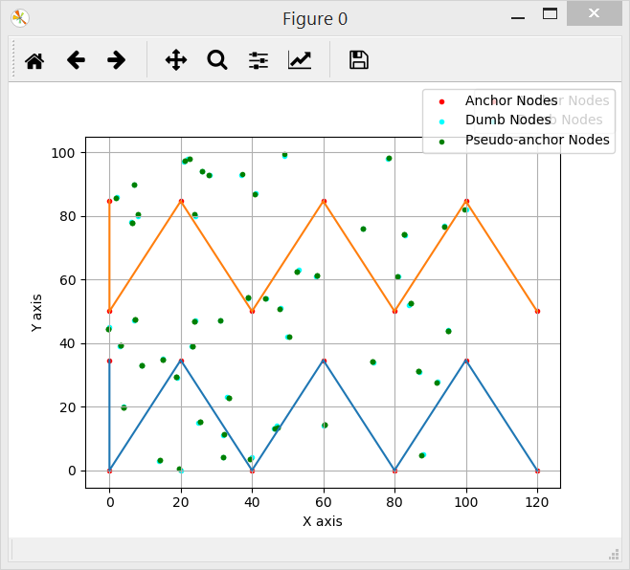

**Figure 24: Graph for Mobile Anchor**

In the above figure, there are two mobile anchors which are following their defined respective path. Any dumb nodes that fall between the range of three coordinates of the anchor, gets localized.

**5.5 Analysis**

|  |  |  |  |  |  |  |
| --- | --- | --- | --- | --- | --- | --- |
| Trial | Algorithm | Number of Anchor Nodes | Number of Dumb Nodes | Number of localized Nodes | Time Taken (secs) | Error |
| Trial 1 | Trilateration | 5 | 50 | 45 | 11.36 | 0.34 |
| PSO | 5 | 50 | 50 | 18.5 | 0.015 |
| Trial 2 | Trilateration | 5 | 50 | 47 | 7 | 0.41 |
| PSO | 5 | 50 | 50 | 17.6 | 0.014 |
| Trial 3 | Trilateration | 5 | 50 | 43 | 8.20 | 0.38 |
| PSOs | 5 | 50 | 50 | 19.3 | 0.0153 |
| Trial 4 | Trilateration | 5 | 50 | 43 | 12.36 | 0.35 |
| PSO | 5 | 50 | 47 | 23.5 | 0.0149 |
| Trial 5 | Trilateration | 5 | 50 | 41 | 10 | 0.42 |
| PSO | 5 | 50 | 50 | 19.6 | 0.0146 |
| Trial 6 | Trilateration | 5 | 50 | 40 | 8.30 | 0.36 |
| PSO | 5 | 50 | 48 | 18.9 | 0.0151 |
| Trial 7 | Trilateration | 5 | 50 | 46 | 11.55 | 0.33 |
| PSO | 5 | 50 | 50 | 18.85 | 0.0141 |
| Trial 8 | Trilateration | 5 | 50 | 47 | 9 | 0.42 |
| PSO | 5 | 50 | 50 | 18.6 | 0.0142 |
| Trial 9 | Trilateration | 5 | 50 | 49 | 8.10 | 0.39 |
| PSOs | 5 | 50 | 50 | 17.3 | 0.0152 |
| Trial 10 | Trilateration | 5 | 50 | 48 | 12.36 | 0.35 |
| PSO | 5 | 50 | 50 | 23.5 | 0.0150 |

Mean Error of PSO = 0.0147 Mean Time Taken for PSO = 19.56

Mean Error of Trilateration = 0.375 Mean Time Taken for Trilateration = 9.823

|  |  |  |  |  |  |  |
| --- | --- | --- | --- | --- | --- | --- |
| Trial | Algorithm | Number of Anchor Nodes | Number of Dumb Nodes | Number of localized Nodes | Time Taken (secs) | Error |
| Trial 1 | Trilateration | 5 | 50 | 46 | 15.6 | 0.380 |
| PSO | 5 | 50 | 50 | 25.6 | 0.0141 |
| Trial 2 | Trilateration | 5 | 75 | 74 | 15.5 | 0.412 |
| PSO | 5 | 75 | 75 | 28.2 | 0.0142 |
| Trial 3 | Trilateration | 5 | 100 | 93 | 16.8 | 0.366 |
| PSOs | 5 | 100 | 100 | 29.3 | 0.0151 |
| Trial 4 | Trilateration | 8 | 50 | 44 | 15.36 | 0.378 |
| PSO | 8 | 50 | 50 | 28.02 | 0.0149 |
| Trial 5 | Trilateration | 8 | 75 | 70 | 15.64 | 0.395 |
| PSO | 8 | 75 | 74 | 36.8 | 0.0148 |
| Trial 6 | Trilateration | 8 | 100 | 96 | 31.26 | 0.366 |
| PSOs | 8 | 100 | 100 | 59.29 | 0.0150 |
| Trial 7 | Trilateration | 10 | 50 | 46 | 15.54 | 0.386 |
| PSO | 10 | 50 | 50 | 24.44 | 0.0141 |
| Trial 8 | Trilateration | 10 | 75 | 72 | 15.62 | 0.409 |
| PSO | 10 | 75 | 75 | 31.65 | 0.0143 |
| Trial 9 | Trilateration | 10 | 100 | 94 | 17.62 | 0.386 |
| PSOs | 10 | 100 | 98 | 62.85 | 0.0151 |

# 6. Project Costing

## Introduction

From the all the previous chapters we designed, implemented and tested our project applying different cases. After implementation of algorithm. Now in this chapter we estimate the total cost to design and implement the project. And also, the labour cost will be estimated.

**6.2 Project Cost**

Man hours per week (students): 18 *4 students =72

Making Cost: Rs 0

Labour cost: Rs 0

* 1. **Summary**

In this chapter, the details about the project costing has been given. This chapter also contains the information of the labour cost. The net total cost including the project cost and the labour cost has been provided.

# 7. Conclusions and Suggestions for Future Work

The project is for Application of metaheuristics for localization, energy and path optimization in Sensor Network. The project mainly focuses on comparing the traditional approaches with the bio-inspired approaches in dealing with the three issues which are – path planning, localization and energy optimization. By focusing on the central topic of the project, the project goal has been achieved. It is implemented and simulations has been tested. SI algorithms has been applied to achieve accurate location estimation, energy optimization and deployment of sensors in WSN. By completion of this project, the difference between the two approaches has been known. Finally, people will start using the better approach.

The scope of the project was to apply SI algorithms to achieve accurate location estimation, energy optimization and deployment of sensors in WSN. The localization issue of WSN has been solved using PSO. Path Planning issue has been solved using Trilateration. Energy Consumption issue has been solved using LEACH Protocol.

For the implementation and testing of the simulations, Python will be used. It is mainly used for implementation. Here, test scenarios with known data and unknown data. In order to perform comparative analysis of traditional deterministic algorithm, the bio-inspired SI algorithms are considered which increases the efficiency of SI Algorithm and energy Consumption of Wireless Sensors. The project also aims to perform comparative analysis of traditional deterministic algorithms with bio-inspired SI algorithms.

The future scope of the project is surveillance of traffic which will determine the amount of traffic at different junctions at different points in time. Sensor will sense high traffic in a particular area and then the information will be transmitted to the base station incorporating LEACH protocol. Localization will be done using PSO to get the accurate location of the sensor that sensed high traffic and then accordingly that information can be used for different purpose. Also, detection of fire in forest, detection of landslides in different area, in animal habitat, etc are the few area where this project can be used.

**References**

[1]Carlos-Mancilla, M., López-Mellado, E. and Siller, M. (2016). Wireless Sensor Networks Formation: Approaches and Techniques. Journal of Sensors, 2016, pp.1-18.

[2] Ijcsmc.com. (2019). [online] Available at: https://ijcsmc.com/docs/papers/June2014/V3I6201499a20.pdf [Accessed 12 April 2019].

[3] Ieeexplore.ieee.org. (2019). LEACH Protocol and Its Improved Algorithm in Wireless Sensor Network - IEEE Conference Publication. [online] Available at: https://ieeexplore.ieee.org/document/7864272 [Accessed 22 March 2019].

[4] Dorigo, M. (2007). Ant colony optimization. Scholarpedia, 2(3), p.1461.

[5] Swarmintelligence.org. (2019). Particle Swarm Optimization: Tutorial. [online] Available at: http://www.swarmintelligence.org/tutorials.php [Accessed 18 April 2019].

[6] Kennedy and R. Eberhart, Particle swarm optimization, in Proceedings of the IEEE International Conference on Neural Networks, vol. 4

[7] Nov 1995, pp. 1942–1948Akyildiz, I. F., Su, W., Sankarasubramaniam, Y., Cayirci,

E.Wireless sensor networks: a surveyComputer Networks2005384393422.

[8] Shweta Gupta, Kumar Saurabh, "Artificial mountain ape optimization algorithm

for maximum power point tracking under partial shading condition", Energy

Communication Data Analytics and Soft Computing (ICECDS) 2017 International

Conference on, pp. 796-801, 2017.

[9] V. R. Kulkarni and V. Desai, "ABC and PSO: A comparative analysis," 2016 IEEE

International Conference on Computational Intelligence and Computing Research

(ICCIC), Chennai, 2016, pp. 1-7. doi: 10.1109/ICCIC.2016.7919625

[10] Kulkarni, V.R., Desai, V. & Kulkarni, R.V. Wireless Networks (2019).

https://doi.org/10.1007/s11276-019-01994-9